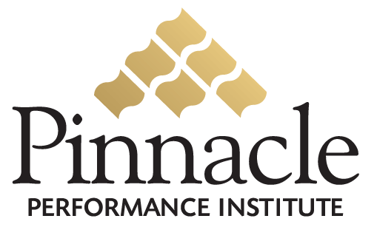

Performance Enhancement

Solution
FOR
Compliance Certification
&
Leadership Building

To Close the Gap between Vision & Execution
Expose Reality… then Act Upon It!



Financial Brokers Group
2562 Boardwalk Ave.
San Antonio, TX 78217
Attn: Arturo Valdez
210-828-3000

Table of Contents

Executive Summary 2
Execution Strategy 3
Overview 3
Opportunity 3
Solution 4
Return On Investment 6
Implementation Plan 7
Pinnacle Performance Institute 8
Agreement 9

Executive Summary
Financial Broker Group (FBG) is a marketing organization offering financial based products and concepts to the American people. FBG having formed alliances with some of the best companies and marketing groups the industry has to offer, has created solutions to help clients grow their financial portfolios from their basic financial needs to the most advanced needs. The FBG approach is to build a financial foundation not just sell a product. It's all about planning. Planning for today and the future. It's the power of knowledge and gathered assets. With applied knowledge and wisdom equals power! FBG believes that each person and family has unique challenges in the game of life. By offering an extensive array of diversified products represented by well-known financial companies, FBG associates are better able to meet the unique challenges of each family on an individual basis. Therefore by working together with clients FBG provides financial strategies to harness the POWER that drives individual DREAMS and GOALS.
FBG desires to expand its client base through expanding its base of qualified and effective associates. Increasing the number of qualified associates and insuring their success through optimum performance will improve the quality of life of the FBG clients, the FBG associates and the overall financial stability of the organization.
Pinnacle will develop a custom FBG branded Business Performance Solution to enable FBG to assist its associates in improving their service to their clients; increase their customer referrals, associate retention, associate productivity and sales conversion rates. FBG associates will have unlimited access to the Pinnacle Buffet of Fortune 500 quality development and management courses.
Additionally, industry providers, vendors and expert technicians will be able to provide their comprehensive training to the FBG associates through the FBG Business Performance Solution. FBG associates may join the FBG Business Performance Solution with unlimited access to all assessments, Pinnacle course buffet and communication programs for a small

Execution Strategy
Pinnacle is dedicated to the successful integration of the Pinnacle Performance Solution within Financial Broker Group (FBG). The certification and performance benefits can contribute significantly to FBG’s regulatory compliance requirements and growth and profitability objectives. For FBG to fully realize the wide-ranging benefits of its Pinnacle Performance Solution, the following principles must be embraced.

Performance Solution
Your solution can significantly improve the overall performance of the entire organization including the company management, employees and independent agents. You can effectively measure the strengths and weaknesses of all agents. The results of the metrics will drive the effective application of the necessary development to build confidence and competence. The continual process of measuring and building is enabled with effective communication and accountability. When used as a platform for implementing change your Performance Solution will deliver maximum value, well beyond that of a video training library.

Performance Culture
Your performance solution is integral to the successful improvement of the entire organization. Performance must become integrated within the culture and mindset of every agent, employee, manager and executive. In order to “Close the Gap between Vision and Execution”, FBG must expose reality… and act upon it. This requires a comprehensive implementation plan rather than just another peripheral program.

Performance Commitment
Regardless of how great your performance solution is, your ultimate success will be completely dependant on the level of commitment from everyone involved including the top management down to the front-line employees and agents representing the executed vision of the company. Each user of the performance solution must have a personal commitment and buy-in, through accountability, incentive programs and/or monetary commitments. Complete user commitment will overcome the challenges leading to integration failure contributed to a lowered priority and lowered perceived value.

Overview
Financial Broker Group (FBG), a direct sales company, marketing financial service products in the U.S.. FBG has more than 1,500 independent agents, spanning all ages and all skill levels. Agents represent a diversified group of men and women who are working together to exchange ideas, advance their skills, increase their knowledge, and realize their dreams.

Opportunity
FBG recognizes the significant need to train and certify their independent agents on regulatory requirements to protect the company from legal liabilities due to unauthorized product claims, earning statements and business practices, etc. FBG also recognize the need to insure that agents are qualified to represent the company and that they are equipped to excel at their responsibilities.
FBG Agents can significantly increase their likelihood of success with business assistance to lift the burden of supporting and running a successful business; and a proven formula for success to create sales, develop marketing, and manage their business.

Solution
Pinnacle will develop a custom FBG branded Performance Enhancement Solution to enable FBG to train and certify their agents on regulatory requirements, qualified agent compliance, and the necessary business skills for success.
FBG will assist its agents in improving their business development; increase their customer referrals, agent retention, agent productivity and sales conversion rates. FBG agents will have unlimited access to the growing Pinnacle Buffet Library currently listing over 800, Fortune 500 quality development and management courses in addition to the FBG specific training and development courses. FBG agents will have full access to the FBG certification programs to insure their agent qualification.
The FBG Performance Enhancement Solution will provide all aspects of business development to its agents in addition to company specific knowledge and expertise. Company product experts, sales experts, and proven leaders will be able to provide their comprehensive training to the FBG agents through the FBG Performance Enhancement Solution.
FBG agents will be able to significantly improve their performance by constantly measuring their strengths and weaknesses, and applying the necessary development to build confidence and competence. The continual process of measuring and building is enabled with effective communication and accountability.
FBG agents may optionally join the FBG Performance Enhancement Solution with unlimited access to all certifications and assessments, development courses, communication programs and goal management for a small monthly flat-fee of only $34.95. FBG has no setup or support fees and will generate $5 residual revenue through the promotion of their custom Performance Enhancement Solution memberships.
Agents will receive a free 14-day trial membership to access all the solution capabilities. Agents can also complete their certification requirements within the 14-day trial period and are not obligated to continue past the trial period.

Some of the features of the FBG Performance Enhancement Solution include:
General Performance Solution Features
- Accessible anywhere with Internet access
- Accessible anytime 24 hours a day, 7 days a week, 365 days a year.
- Secured Access with personal logon name and password for each user
- Secured back-office for program managers, group managers, trainers and members
- Streaming video training supports dial-up and broadband users
- Single flat fee includes unlimited access to everything
Performance Solution Administration and Management
- Custom graphics, pages, colors and training buddy image & biography
- Custom Groups for specific performance goals (departments, roles, projects)
- Public, Private and Semi-private Groups
- Group inclusion of specific members and required or recommended courses
- Selection of public or proprietary assessments and training courses
- Dynamic Surveys to collect performance feedback from team members and customers
- Online conference rooms and discussion boards for each Group
- Electronic suggestion boxes for each Group
- Define expectations for each Group
- Email Manager to send scheduled messages to select members
- Management reporting on member status, usage, and training accomplishments
- Management reporting on member certification and goal accomplishments.
- Managing Buddy to guide the Manager through the necessary administration.

Member Performance Solution
- Member Profile to maintain contact information and secured logon and password
- Training Buddy to assist with all aspects of the solution
- Personal status tracking of all assessments, classes, communications, etc.
- Accountability goals to establish a culture of execution
- Assessments to measure personal and professional needs
- Diagnostic Assessments to address specific problems/needs
- Training Prescriptions for specific individual needs
- 1000+ public training courses on all aspects of life
- Selected company-specific training courses
- Course ratings and feedback from other members
- Multimedia lessons with downloadable attachments
- Take class notes organized by topic and printable
- Lesson quizzes with multimedia questions
- Company branded professional certificates
- Personal expectations for each accessible group
- Group online conference rooms and discussion boards
- Electronic suggestion boxes with reviewable responses
- Company surveys with anonymous feedback

Trainer Performance Content
- Trainer Profile to maintain contact information, picture and biography
- Unlimited number of company trainers
- Maintain secured logon name and password
- Create courses with unlimited number of lessons
- Lesson content of text & pictures, video, audio, Flash, PowerPoint, website links, etc.
- Downloadable lesson attachments for workbooks and reference sheets
- Lesson Quizzes with unlimited multimedia questions
- Quiz questions are multiple choice, fill-in-the-blank, or true/false
- Create assessments to determine proficiency scores
- Create diagnostic assessments to solve specific problems/needs
- Define training prescriptions for specific needs.
- Unlimited multimedia assessment questions
- Assessment questions are multiple choice, fill-in-the-blank, or true/false

Return On Investment

The FBG will have an estimated investment of $36,000 annually for management and promotion of the solution, Projected revenue for 3000 (1%) memberships at $4 per month will yield an annual profit of $144,000 or 300% Return on Investment.

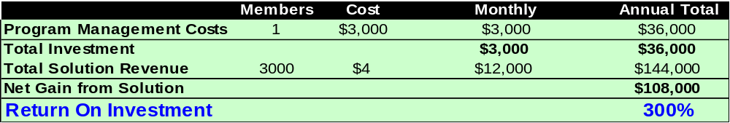

The FBG agent will have an estimated investment of $34.95 monthly for access to the solution. A projected earnings increase of only $500 per month will yield an estimated $6,000 value on a $419 investment or 1431% Return on Investment.

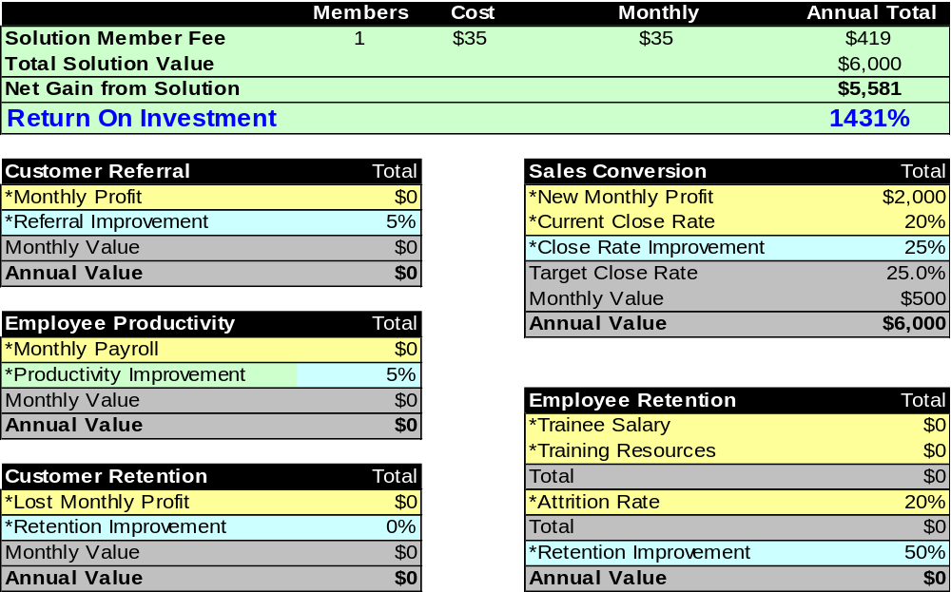

Typical Implementation Plan

Start the implementation on July 1, 2005 and will complete the Planning Phase in 7 days on July 7, 2005. The Setup Phase will be completed in 14 days on July 21, 2005, ready for agents to start using the solution. The Program Manager will thereafter continually enhance the solution content.

July 1, 2005 (7 days)
Planning Phase Summary
- Identify / Interview Program Manager
- Set Expectations w/ Program Manager and Executive Champion
- Identify Key Players (group managers, influencers, trainers)
- Train Program Manager (phase 1)
- Involve Key Players (advisory group)
- Define Initial Groups and Rollout Priority (departments, roles, projects)
- Define Measurement Needs (existing? create?)
- Define Training Needs
- Define Training Options (existing? create?)
- Define User Expectations (per group)
- Define Promotion Plan (team buy-in)

July 7, 2005 (14 days)
Setup Phase Summary
- Train Program Manager (phase 2)
- Train Group Managers
- Train Trainers
- Setup Folders
- Create Courses
- Create Assessments
- Create Members
- Include Courses
- Include Members
- Start Promotion
- Provide Member Logon Access
- Train Members

July 21, 2005

Usage Phase Summary

MEASURE
- Assessments and Surveys
- Company Gap Assessment
- Knowledge Capital Audit
- Personal Assessments
- Monitor Member Usage
- Review Monthly Reports
- Performance Improvements

BUILD
- Training Buddy of the Month
- Review Measurement Needs
- Review Training Needs

COMMUNICATE
- Monitor Suggestions
- Monitor Conference Rooms
- Monitor Discussion Boards
- Manage Surveys
- Promotion

Pinnacle Performance Institute
The Pinnacle Performance Institute shows companies how to clone their top performers to significantly increase their profits. It does this with a very affordable online Performance Enhancement Solution customized to their specific needs in order to Measure their strengths and weaknesses, Build confidence and competence, Communicate the strategic direction, and Accountability to establish a culture of execution. The Pinnacle Performance Solution empowers companies to Close the Gap between Vision and Execution by exposing reality... and acting upon it.
Companies can benefit from Pinnacle’s dedicated technical and business expertise in delivering a professional quality solution to maximize the performance of the Company, allowing the customer to continue to focus on their core competency.
Pinnacle provides advanced technology architected for large enterprises to support scalability with multi-tier client-server architecture, flexibility for quick modification to meet changing business requirements, maintainability with industry standard technology, and dynamic multi-lingual support for international markets.
Pinnacle provides a quality solution ready to implement immediately to capitalize on the current window of opportunity. Pinnacle overcomes the challenges that all companies face in developing the necessary systems to meet their fast-paced and ever-changing business objectives. Comparable systems can take a development team 12 to 18 months at least to design, develop and deploy, assuming they have the technical and business expertise.
The Pinnacle Performance Institute, headquartered in Plano, TX, is a premier technology company with a passion for performance. Pinnacle leverages technology in assisting companies to “Close the Gap” between their vision and their execution.
The Pinnacle Performance Institute was founded and architected by Mr. Robert A. Wood. He has been a senior technologist for over 20 years with both Ross Perot and Bill Gates and founded Shabang.com during the Internet gold-rush, raising $15M and building it to a $200M corporation. He also founded the underlying technology company, WinTech, Inc. in 1995 and has served as its President & CEO from its inception.
Mr. Wood served as the Chief Technology Officer, President & CEO, and Chairman of the Board of Directors for Shabang.com, an online e-commerce solution for merchants. From 1990 to 1995, Mr. Wood served as Senior Consultant and Developer with Microsoft Corporation. While at Microsoft he was responsible for assisting both the management and technical staffs of Fortune 500 corporations in understanding, architecting and constructing distributed application architectures. Mr. Wood was president of Executive Micro-Systems from 1988 to 1990 and a systems engineer for Electronic Data Systems Corporation (EDS) from 1985 to 1988.

Agreement

Financial Broker Group
2562 Boardwalk Ave.
San Antonio, TX 78217
Attn: President
210-828-3000

X | Bill Members Directly |  | Bill Customer For All Memberships |  |  |  | Bill Credit Card |  |  | Bill Electronic Check

I understand that Pinnacle agrees to:
- Provide the Customer with a private-labeled Pinnacle Performance Enhancement Solution to train and monitor its members, employees and/or independent agents.
- Provide the Customer with a secured Internet back-office to customize and maintain its Pinnacle Solution.
- Provide the Customer’s members with secured Internet access to the Pinnacle Solution.
- Maintain an independent Customer relationship, preventing any suggestion of Customer endorsement.
- Maintain confidentiality of all customer and member personal and financial information. Such identified confidential information will only be used to fulfill the Pinnacle Solution service.
- Recognize Customer ownership of the original content while maintaining ownership of its digital conversion.
- Reserve the right to approve or disapprove any and all training content according to the appropriateness for its members at the complete discretion of Pinnacle.
I agree to:
- Provide a Program Manager for all setup needs and ongoing system and member maintenance.
- Provide the required certifications and necessary training and development courses for the members.
- Provide regular major promotions for the member usage of the solution.
- Ensure that only one individual and their immediate family members utilize each membership account.
- Pay additional monthly fees per account for direct billing to members.
- Maintain an independent relationship with Pinnacle and prevent any suggestion of endorsement by Pinnacle.
- Maintain full and complete ownership of the original intellectual property content granting the nonexclusive right to Pinnacle to edit and convert the original content into a digital format appropriate to Pinnacle’s needs.
- Warrant that I have complete legal rights and authority to provide the training content and am not infringing any copyright or other such laws.
- Issue written notification to Pinnacle of my termination of this agreement effective within thirty days of notice.

My signature indicates that I have read and accept all the terms and conditions regarding privileges and obligations of the Pinnacle Performance Enhancement Solution as outlined on this agreement. I hereby authorize Pinnacle to initiate credit and debit entries to the specified account(s) at the specified depository(s). This authorization is to remain in force until Pinnacle has received written notification from me of my termination in such time and in such manner as to afford Pinnacle and the depository reasonable opportunity to act upon it.

Signature Date

President

